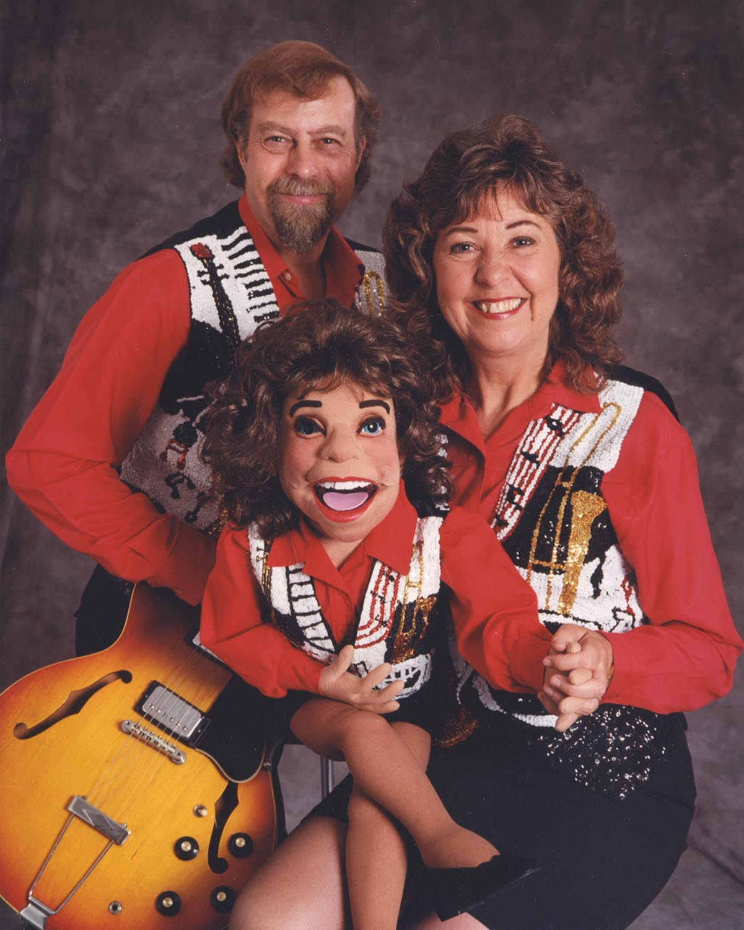

MUSIC

Classic Country
Big Band
Vaudeville
Celtic
50’s / 60’s
and more….

VENTRILOQUISM

COMEDY
DATE:
TIME:
WHERE:

LONDON – FRANKFURT – TORONTO – LAS VEGAS – EDMONTON – CRUISES

www.peterandmary.net

